**ONLINE EXAMINATION SYSTEM**

**COURSE NAME**: Database management system for Designing

**COURSE CODE:** CSA0541

**COURSE FACULTY :** K. Bala Maheswari

**SLOT-C**

D. Avinash (192211736)

N. Omkar (192211664)

S. Manikantha (192225051)

**INTRODUCTION:**

ONLINE EXAMINATION SYSTEM is an online test

simulator to take online examination, test in an efficient manner and no time

wasting for manually checking the test paper. The main objective of this web

based online examination system is to efficiently evaluate the student

thoroughly through a fully automated system that not only saves a lot of time

but also gives fast and accurate results. For students they give papers according

to their convenience from any location by using the internet and time and there

is no need for using extra things like paper, pen etc.

Functional Specification:

Registering new Student

Getting the student and staff info and storing it to databases

Getting the type and number of question paper

Generating results after the exam.

An online examination system project for a Database Management System

(DBMS) is a web-based system designed to conduct exams online. The project's

primary objective is to provide an efficient and automated system for evaluating

students, reducing human intervention and potential errors. The system enables

students to take exams conveniently from anywhere, eliminating the need for

physical presence and materials like paper and pens. The project aims to

improve the overall efficiency and effectiveness of educational assessment

while minimising environmental impact and cost. Additionally, the project aims

to develop expertise in data management fundamentals and database design

techniques. The system's components typically include a web server and an

online platform for conducting exams. The database design involves structuring

tables, defining relationships, and optimising data storage. The system's

functional specifications include registering new students, storing student and

staff information in databases, generating different types of question papers, and

providing exam results after completion. The project's benefits include fast and

accurate results, reduced costs associated with printing and distribution of exam

materials, improved flexibility and scalability, personalised learning

experiences, quick references and easy access to past exams for review

purposes, and streamlined administrative processes.

Online Examination Systems are technology-driven platforms that simplify

examination activities by defining exam patterns, conducting exams in a

paperless manner, and generating instant results for objective questions. These

systems are cost-effective, scalable, and accessible via desktops, laptops, or

mobile devices with a browser. They offer various types of exams like

admission tests, coding tests, mock tests, and more. Online exams can be

conducted remotely with features like remote proctoring for monitoring

candidates. The system ensures security through features like secure view-only

access and encrypted storage. Benefits include convenience, flexibility, security,

efficiency, and customization

Key components of an online examination system typically include exam

creation, delivery, monitoring, grading, and analysis. Advantages of these

systems include convenience, flexibility in scheduling exams, security measures

to prevent cheating, efficiency in grading exams automatically, and

customization for tailored assessments

Online examination systems have gained popularity due to their ability to

provide instant results, eliminate manual workload associated with paper-based

tests, and offer various question types for interactive assessments. These

systems are used by educational institutions, corporations, governments, and

coaching institutes to conduct assessments efficiently Online Exam System is a full-fledged system which is beneficial for both teachers and students. With this site, Administrator can allow authorised entry of users which includes faculties and students. Online Exam System is a web application that establishes a network between

the faculties and students. Faculties enter on the site the questions they want in

the exam. These questions are displayed as a test to the eligible students. The Online Exam System provides the platform but does not directly participate in, nor is it involved in any tests conducted.

**OBJECTIVE:**

The objective of an online examination system is to provide a platform for conducting assessments or examinations digitally, eliminating the

need for traditional pen-and-paper methods. This system aims to streamline the

exam process, improve accessibility for students, enhance security measures,

automate grading, and provide instant feedback to both students and instructors.

Additionally, it aims to save time and resources for educational institutions

while maintaining integrity and fairness in the assessment process. The Online test System is developed using Asp.net and SQL fully meets the

objectives of the system for which it has been developed. The system has

reached a steady state where all bugs have been eliminated. The system is

operated at a high level of efficiency and all the teachers and users associated

with the system understand its advantage. The system does the problem. It Was

intended to soles requirement specification. To appear for an exam in the

manual system in a university is a very time-consuming process. The purpose of

this system is to overcome the shortfall faced in the previous system already

working in the area. The website will have to be secure and properly working on

WAN. It should be speedy with a good interface. The university may conduct

examinations in various countries and in different languages. It should support

multiple platforms, at least those used by people commonly. The main objective

of the online examination system is to provide equal opportunity to every

student who is not going to the exam due to the lack of geographical areas. If

you are regularly watching tv in India, you show one advertisement about online

education to remove geographical barriers. In the Ad, one girl is living in the

mountain region and can’t go to the learning institute due to the lack of

infrastructure (buses or transport). So, with the help of mobile and internet, the

girl educates herself and prepares for her future.

The objectives of an online examination system include: User-friendly system

Responsive design

Offering several types of questions

Auto exam publish

Some key advantages of online examination systems are:

❖ Convenience: Exams can be taken from anywhere with an internet connection.

❖ Flexibility: Exams can be scheduled and taken at any time.

❖ Security: Features are included to prevent cheating and ensure exam integrity.

❖ Efficiency: Exams can be automatically graded, saving time and resources.

❖ Customization: Systems allow for tailored exams to meet specific needs

\

**LITERATURE SURVEY**

Computerised systems have been increasing in education nowadays.

Information Technology plays a very important role in education. Computers

have made dramatic changes in the learning system. Information technology

enables education institutions to save space and time, and allow the delivery of

education services with ease, anywhere, and anytime. For instance, physical

libraries are replaced by online libraries available to anyone; anywhere in the

world students can interact with lecturers online whether live or via video. With

computer software, we can be able to have access to huge databases of

information. This gives fundamental change to the education system.

Information technology makes the exchanges of information fast and easy. With the growth of IT a lot of data can be found in online libraries. We don't

need to have a physical library in order to read books. Computers are a powerful tool used in all aspects of our studies. We use multimedia technologies to

convey ideas, build projects. Information technology enables students to do distance learning, a method of

learning at a distance instead of learning in a classroom. Communications

technologies create possibilities, both individual and institutional, for an

unprecedented expansion of home-based learning, much of it part-time. Information technology provides systems that allow students to perform many

tasks in an automatic way and not manually. Students can take exams using a

computerised system; they don’t need a paper-based exam. They save time and

money when using computer system in their studies

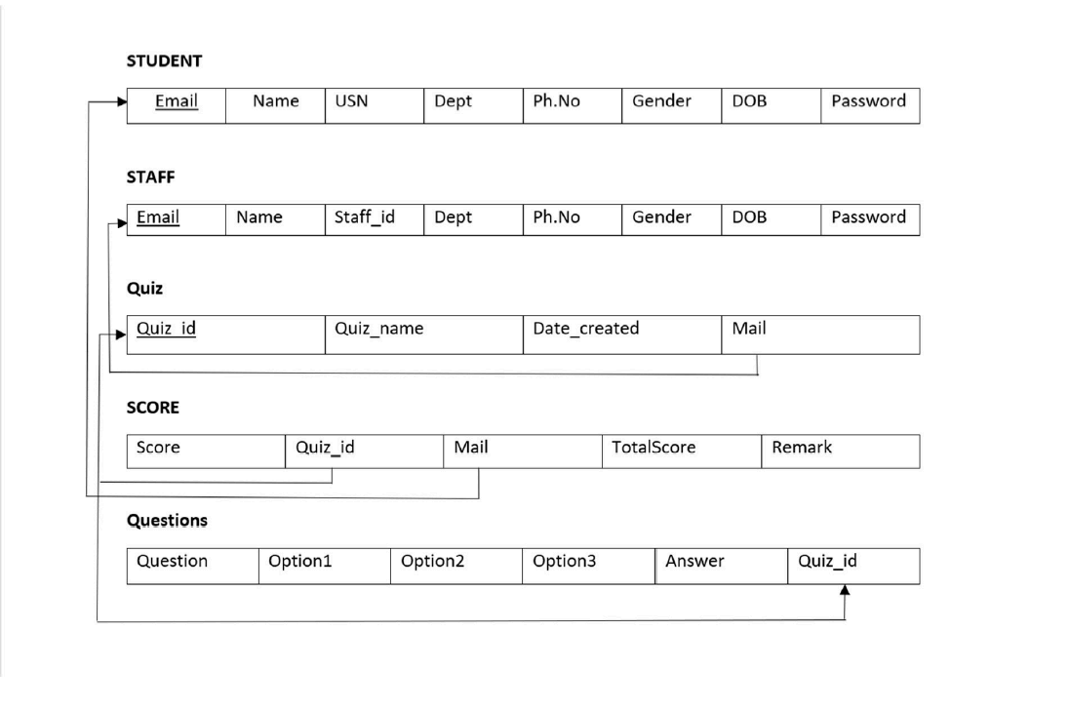

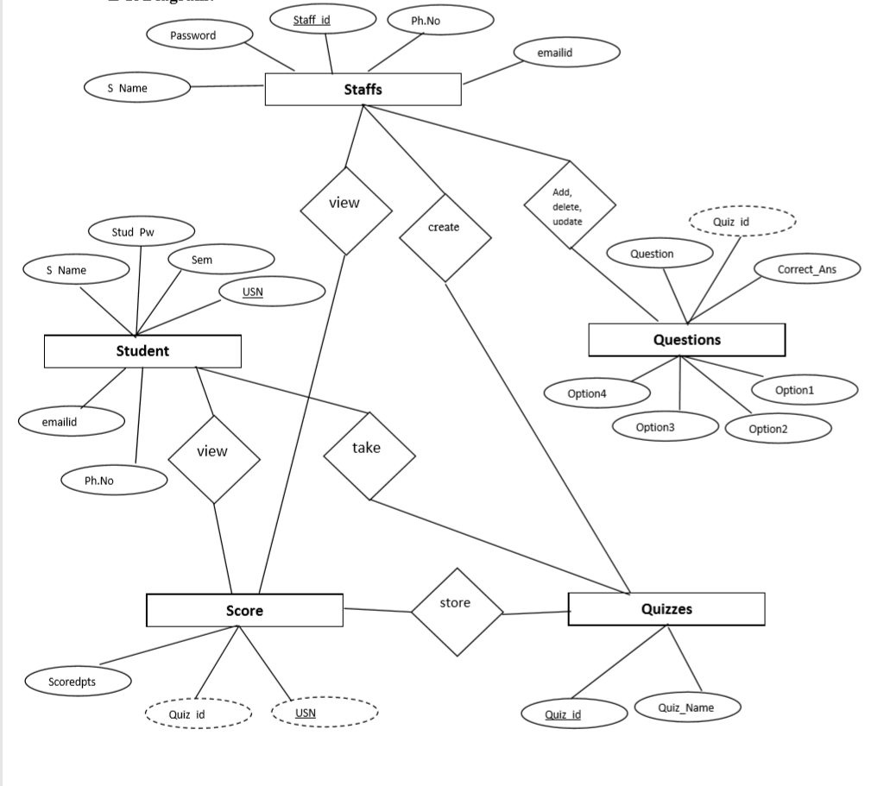

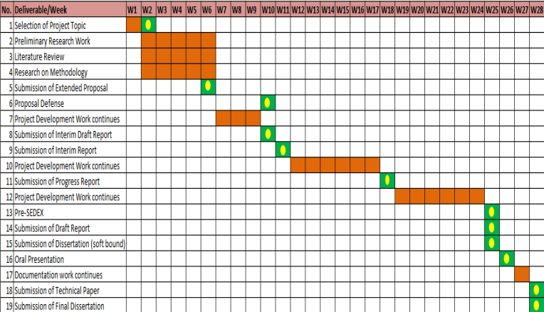tures are included to prevent cheating and ensure exam